Team Ctrl-Alt-Delete
Third Iteration Deliverables

Pivotal Tracker:
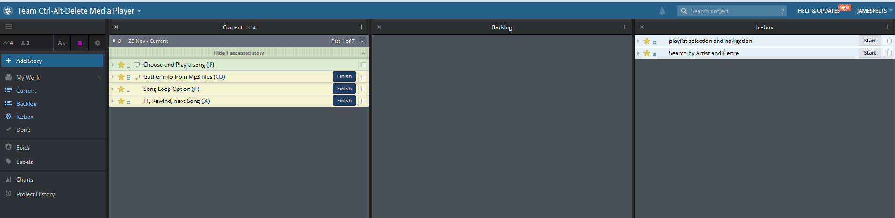
Git Usage:
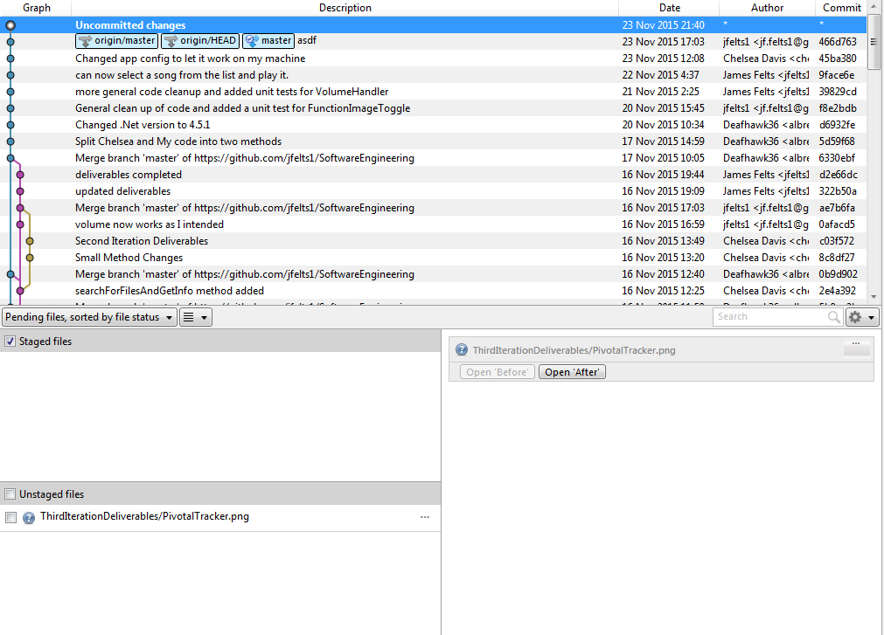

Populating the List Box:
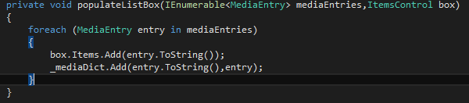
Play Selected Media:
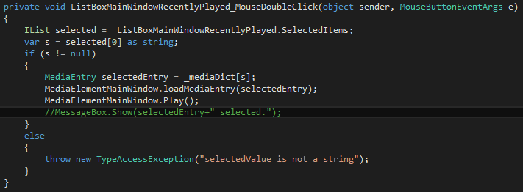
MediaElement Extensions:
